DataAnalyticsWithTableau

**Name : G.Jayachandra**

**Team Member – 3 Assignment - 2**

*SupermarketSalesDataAnalysisReport–TableauVisualizations*

1. **DonutChart–SalesbyProductLine**

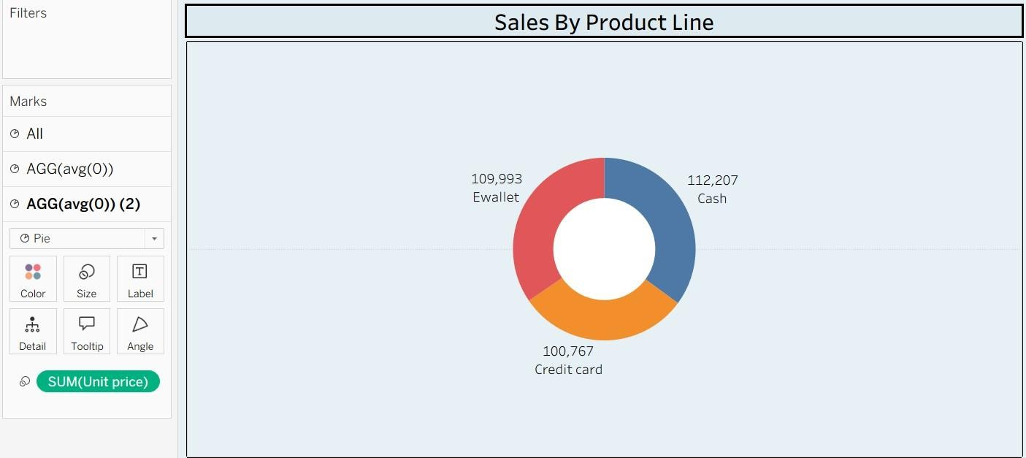

1. 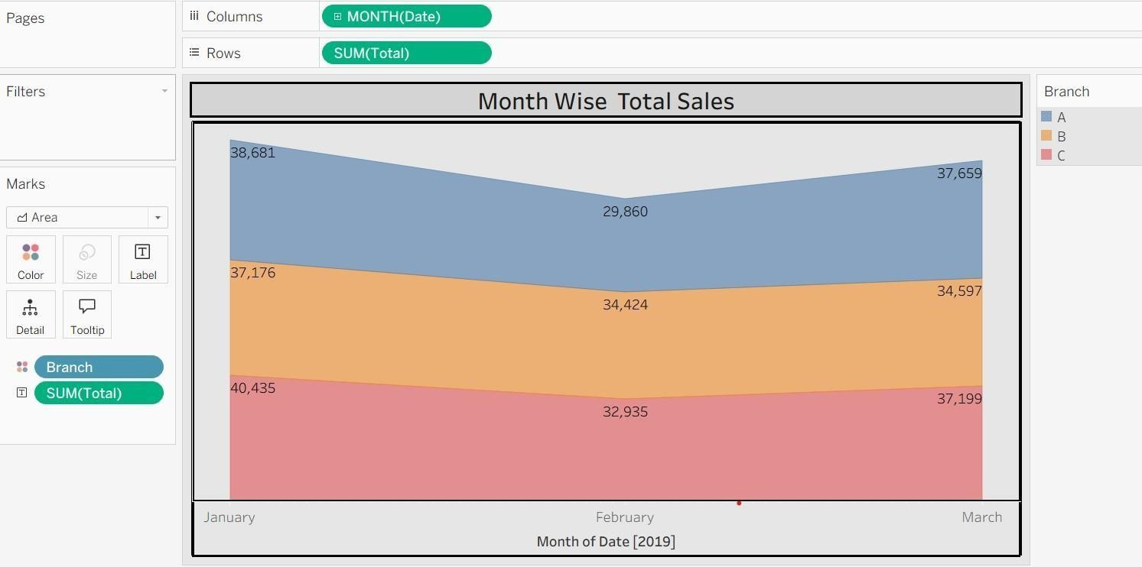**Chart–SalesbyProductLine**
2. **TextTable–Branch,City&ProductLine**

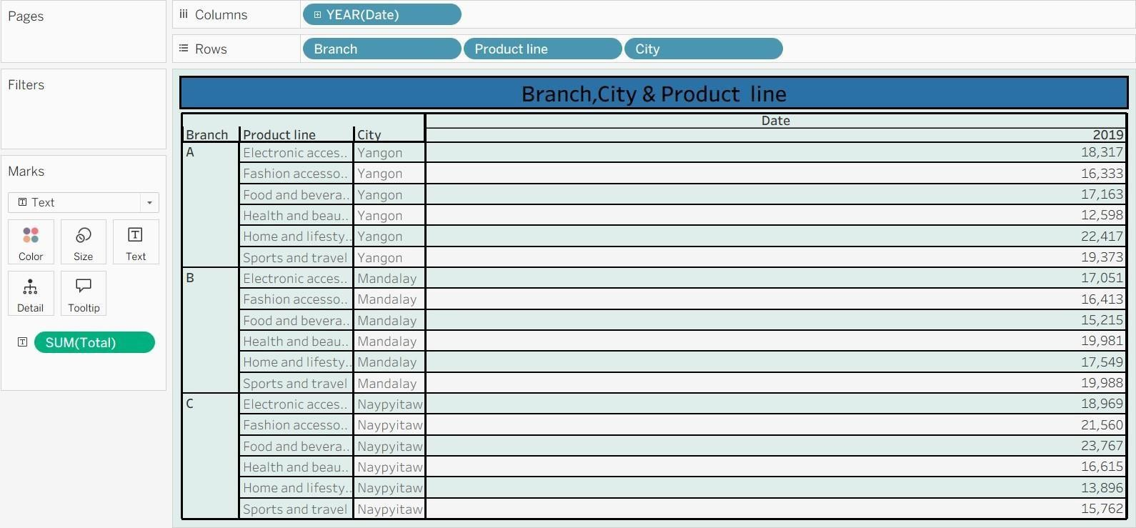

1. **HighlightedTable–BranchWiseSalesbyProductLine**

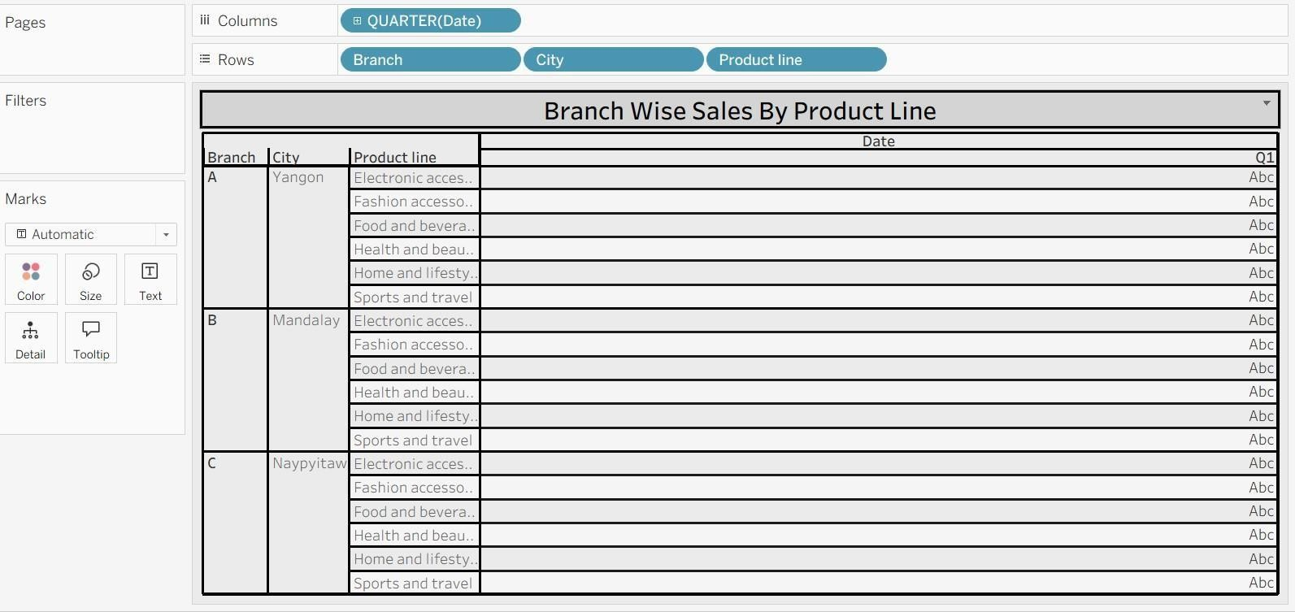

1. **WordCloud–TopProductLinesbySales**

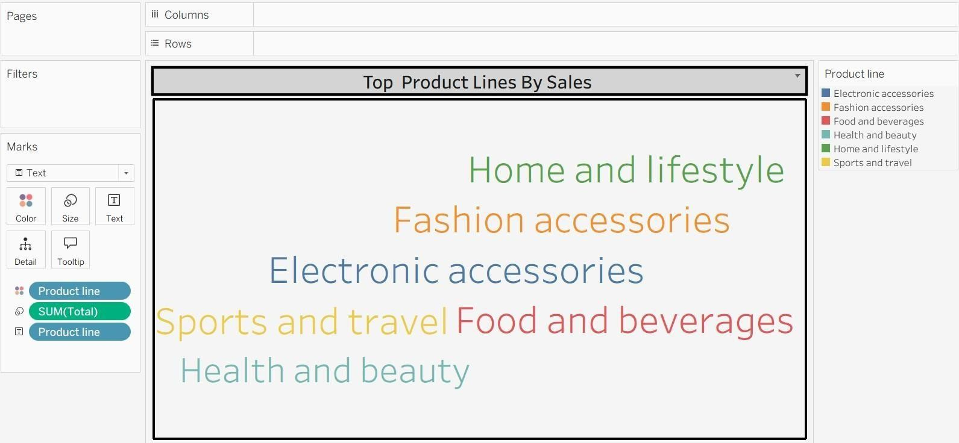

1. **FunnelChart–TotalSalesbyProductLines**

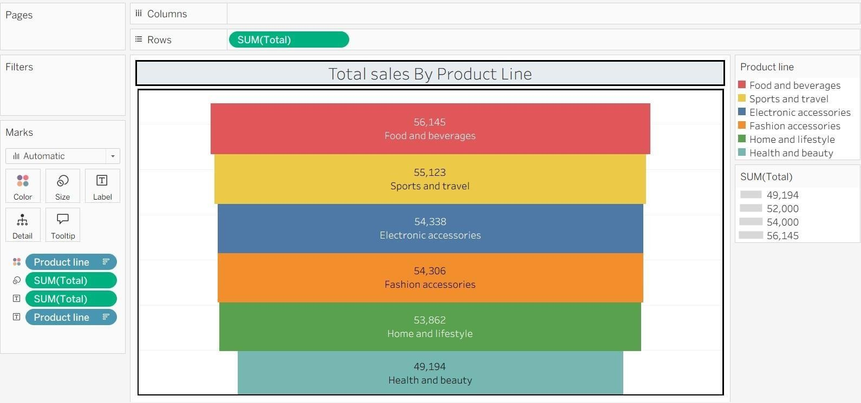

**-**

1. **WaterfallChart–TotalSalesContributionbyProductLine**

